**Business Intelligence Solution for Sales Data Management**

**and Analysis**

**Problem Statement:**

A small company Axon, which is a retailer selling classic cars, is facing issues in managing and analyzing their sales data. The sales team is struggling to make sense of the data and they do not have a centralized system to manage and analyze the data. The management is unable to get accurate and up-to-date sales reports, which is affecting the decision-making process.

To address this issue, the company has decided to implement a Business Intelligence (BI) tool that can help them manage and analyze their sales data effectively. They have shortlisted Microsoft Power BI and SQL as the BI tools for this project.

**Abstract:**

The project titled "Business Intelligence Solution for Sales Data Management and Analysis" addresses the challenges faced by Axon, a small retailer specializing in classic cars, in effectively managing and analyzing their sales data. Axon's sales team struggles with the complexity of the data, leading to difficulties in decision-making processes. To tackle this issue, the company has chosen to implement a Business Intelligence (BI) solution leveraging Microsoft Power BI and SQL.

**This capstone project encompasses the following key objectives:**

1. Extract, clean, and integrate sales data from a MySQL database into Power BI.

2. Design interactive dashboards and reports using Power BI to enable the sales team and management to gain insights into the data.

3. Utilize SQL for advanced analytics to extract valuable insights to enhance sales strategies.

4. Enable real-time access to dashboards and reports to empower data-driven decision-making.

5. Ensure a user-friendly solution that enhances sales data management and analysis.

The project's workflow involves creating a MySQL database named "classicmodels," extracting, cleaning, and loading data into Power BI, designing data visualization and analysis tools, testing and debugging the solution, and deploying it for practical use. User training and comprehensive documentation are essential components of the deployment phase.

By addressing these objectives, this project offers Axon a robust and accessible tool for managing and analyzing sales data, ultimately improving their decision-making processes and business performance. The success of this project lies in its capacity to provide a powerful BI solution that enhances Axon's ability to thrive in the competitive classic car retail industry.

**Tools Used in the Project:**

1. Microsoft Power BI
2. MySQL
3. **IMPORTING DATA**

Here We have to export dataset into Power Bi. Given Dataset set is in SQL format. We have to follow below steps:

1.Create a database using MySQL.

2.Import data into Power BI by below steps.

Step1: Click on “get data” on the Ribbon from Home Tab

Step2: Click on Database on the popup then click on MySQL database.

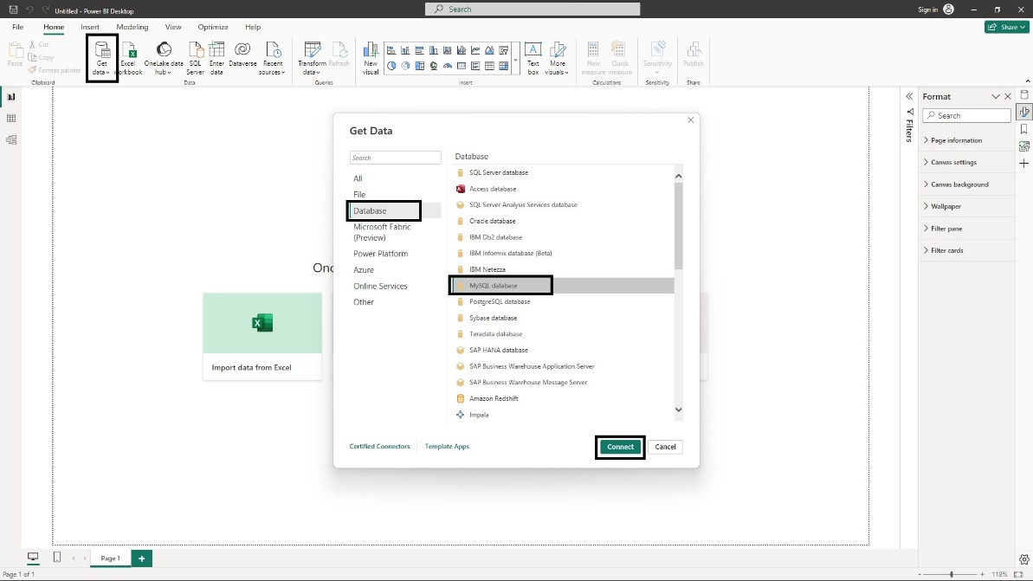

Fig 1(a)

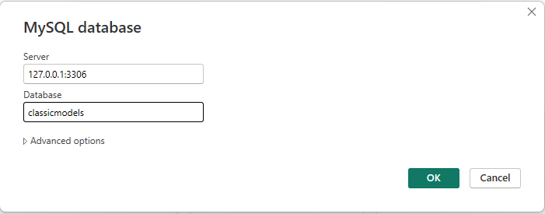Step 3: Enter Server Id and database name then OK.

Step 4: From the Navigator, Select all tables from the dataset.

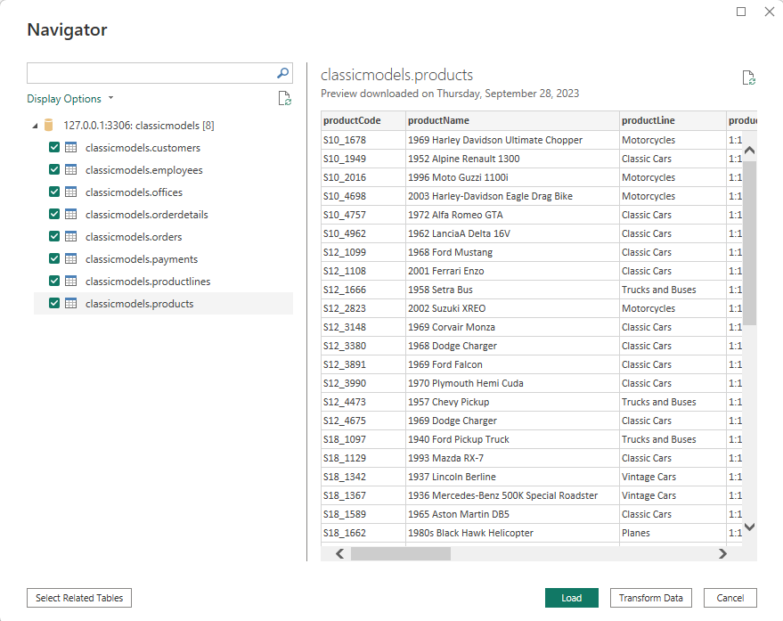

Here, we have to check there is any missing values, wrong data type, need to change columns names first, that’s the reason we have to click on “Transform Data”.

**The dataset consists of following tables:**

1. Customers: Stores customer’s data
2. Employees: Stores all employee details such as id, name, contact information
3. Offices: Stores offices data such as office code, location
4. Orderdetails: Stores sales details such as order quantity, each price, sales of items by order line for each order.
5. Orders: Stores order date, customer information, order status and comments.
6. Payments: Stores payments done by customer
7. Productlines: Store product line of each product and their description.
8. Products: Stores product details such as name, productline, productscale, stock and vendor information.
9. **CLEANING DATA**

**1. Customer Table:**

1. Changed the table name from “classicmodels customers” to “Customers”.
2. Combined the “addressline1” and “addressline2” to “Address” because “addressline2” has more missing values. It didn’t impact on my analysis but I merge them.
3. Replaced the Null values from “State” column by “others”.
4. Replaced the Null values from “postalCode” column by “NA”.
5. Changed the datatype of column “Credit limit” from “Decimal” to “Whole number”
6. Once check all datatypes of columns again then clicked on “Detected data type” in the Ribbon from Transform Tab.
7. Renamed the column “salesRepEmployeeNumber” to

**2. Employee Table:**

1. Renamed table name from “classicmodels employees” to “Employee”.
2. Checked all columns datatypes.
3. Reordered the first name and last name.
4. Merged the “first name” and “last name” as “employeeName”

**3. Offices Table:**

1. Renamed table name from “classicmodels offices”to “Offices”
2. Checked the datatype of all columns no need to change.
3. Merged both “addressline1” and “addressline2” to “Address”.
4. Replaced null values in column “state” to “Others”.
5. Replaced null values in column “territory” to “Others”.

**4. Orderdetails Table:**

1. Renamed table name from “classicmodels Orderdetails” to “Orderdetails”.
2. Renamed column name “quantityOrdered” to “Order Quantity”.
3. Renamed column name “priceEach” to “List Price”
4. Created a custom column “Sales” by multiplying “Order Quantity” and “List Price”.
5. Created a custom column “Cost Price” by multiplying “BuyPrice” and “Order Quantity”
6. Created a custom column “Profit” by subtracting “Sales” and “Cost Price”

**5. Orders Table:**

1. Changed Table name from “classicmodels orders” to “Orders”
2. Checked the datatypes all columns no need to change.
3. Replaced null values in “Comments” to “NA”.
4. Created a custom column “Month” to extract a month from “orderDate”.
5. Created a custom column “Day Name” to extract a day name from “orderDate”.
6. Created a custom column “Year” to extract a year from “orderDate”.
7. Created a custom column “Quarter” to extract a Quarter number from “orderDate”.
8. Removed a custom column “Day Name”.
9. Created a custom column “Short Month” to extract a month from “orderDate”.

**6. Payments Table:**

1. Changed Table name from “classicmodels payments” to “Payments”
2. Checked the datatypes all columns no need to change.

**7. Productlines Table:**

1. Changed Table name from “classicmodels Productlines” to “Productlines”.
2. Checked the datatypes all columns no need to change.
3. Removed null valued columns “htmldescription” and “image” from table.

**8. Products Table:**

1. Changed Table name from “classicmodels Products” to “Products”.
2. Checked the datatypes all columns no need to change.
3. Renamed column name "quantityInStock" to "Stock Quantity".

These are the changes I made for the dataset.

After Cleaning data which loaded into Data Model.

**3. MODEL VIEW**

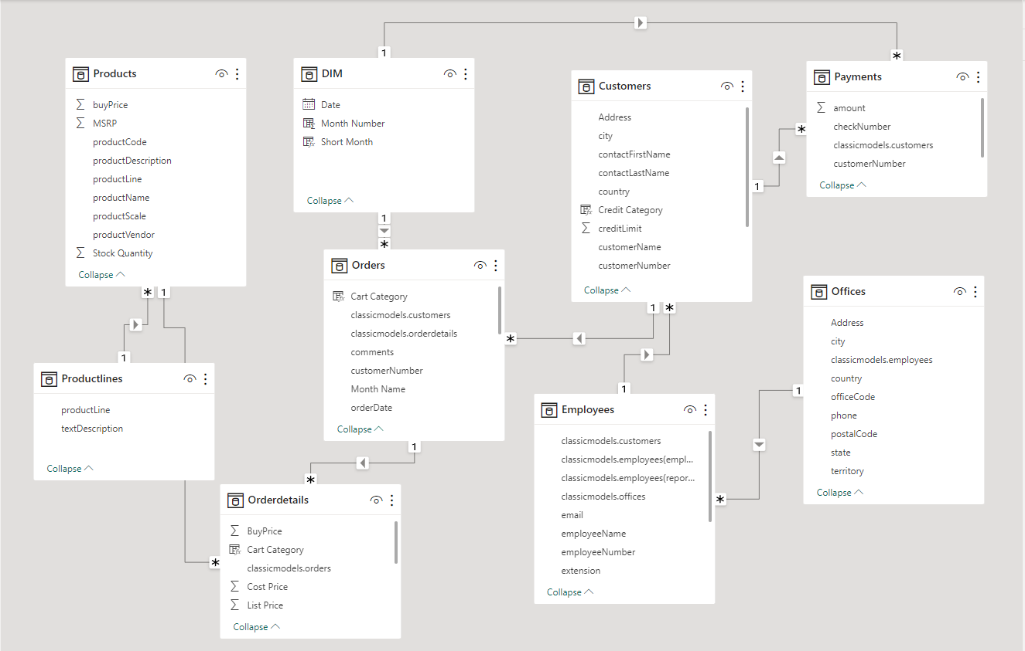

**Fig (2)**

The Fig (2) shows the relation between the tables. The above table represents the snow flake schema.

**1. Relation between the Tables:**

1. **Customers Table:**
   * Having One-to-Many relationship with “Payments” and “Orders” table.
   * Many-to-One Relationship with “Employees” Table.
2. **Employees Table:**
   * Having One-to-Many relationship with “Customers”
   * Many-to-One relationship with “Offices”.
3. **Offices:**
   * One-to-Many Relationship with “Employees”.
4. **Orderdetails Table:**
   * Many-to-One Relationship with “Orders” Table.
   * Many-to-One relationship with “Products” table.
5. **Orders:**
   * Many-to-One Relationship with “Dim Table”.
   * One-to-Many Relationship with “Orderdetails”.
6. **Payments Table**:
   * Many-to-One Relationship with “Customers” and “DIM Table”.
7. **Productlines Table:**
   * One-to-Many Relationship with “Products”.
8. **Products Table:**
   * Many-to-One Relationship with “Productlines”.

**Cross-filter direction:**

All tables having cross-filter direction as “Single” only.

**2. Setting Up Calculated Columns & Tables:**

**1. Dim Table:**

Created a Dimension Table Using Calendar Function.

Syntax:

DIM = CALENDARAUTO()

**2. Short Month Column:**

Created a Short Month from DIM table using FORMAT function.

Syntax:

Short Month = FORMAT(DIM[Date],"MMM" )

**3. Month Column:**

Created a Month from DIM table using MONTH function.

Syntax:

Month Number = MONTH(DIM[Date])

**4. Credit Category:**

Created a “Credit Category” column in Customers Table. That filters the “credit limit” column using SWITCH function into categories i.e.,

* if the credit limit is 0 then it shows “No Credit”.
* if the credit limit is greater than 0 and less than 25000 then “Low Credit”.
* if the credit limit is greater than 25000 and less than 50000 then “Moderate”.
* if the credit limit is greater than 50000 and less than 100000 then “Standard”
* if the credit limit is greater than 100000 then “Premium Credit”.

Syntax:

Credit Category =

SWITCH(

TRUE,

Customers[creditLimit]=0,"No Credit",

Customers[creditLimit]>0 && Customers[creditLimit] <= 25000,"Low Credit",

Customers[creditLimit] > 25000 && Customers[creditLimit] <= 50000,"Moderate",

Customers[creditLimit] > 50000 && Customers[creditLimit] <= 100000, "Standard ",

Customers[creditLimit] > 100000,"Premium Credit"

)

**4. Cart Category:**

Created a “Cart Category” column in Orders Table. That filters the “Cart Value” column using IF function into categories i.e.,

* if the “Cart Value” is less than or equal to 5000 then it shows “Low-Value”.
* if the “Cart Value” is greater than 5000 and less than or equal to 10000 then “Standard”.
* if the “Cart Value” is greater than 10000 and less than 30000 then “High-Value”.
* if the “Cart Value” is greater than 25000 then “Very High”

Syntax:

Cart Category =

IF([Cart Value] <= 5000, "Low-Value",

IF([Cart Value] > 5000 && [Total Sales] <= 10000, "Standard",

IF([Cart Value] > 10000 && [Total Sales] <= 30000, "High-Value",

IF([Cart Value] > 25000,"Very High"))))

**5. Shipping Period:**

Created a “Shipping Period” column in Orders Table. That calculates the difference between Order date and Ship date using DATEDIFF function i.e.,

Syntax:

Shipping Period = DATEDIFF(Orders[orderDate],Orders[shippedDate],DAY)

**5. Cost Parameter:**

Created a “Cost Parameter” Parameter Table in a Data model. That allows to change the input values based on parameter value we defined.

Syntax:

Cost Parameter = GENERATESERIES(-10, 10, 1)

**5. Sales Parameter:**

Created a “Sales Parameter” Parameter Table in a Data model. That allows to change the input values based on parameter value we defined.

Syntax:

[Sales Parameter ] = GENERATESERIES(-10, 10, 1)

**DAX QUERIES**

1. Calculate sum of sales amount

* Total Sales = SUM(Orderdetails[Sales])

1. Calculate Average sales by dividing sum of sales and count of orders.

* Average Sales = DIVIDE(SUM(Orderdetails[Sales]),COUNT(Orders[orderNumber]))

1. Calculate Average Profit by dividing sum of profit and count of orders.

* Average Profit = DIVIDE(SUM(Orderdetails[Profit]),COUNT(Orders[orderNumber]))

1. Calculate Average amount of payments by dividing sum of payment amounts and no.of payments.

* Average Payments = DIVIDE(SUM(Payments[amount]),COUNT(Payments[checkNumber]))

1. Calculate Average Shipping days by calculating average of “Shipping Period”.

* Average Shipping Days = AVERAGE(Orders[Shipping Period])

1. Calculate the customer who having no sales by Filtering the Customers table where the sales are zero.

* Customers Having No Sales = COUNTROWS(FILTER('Customers',

COUNTROWS(RELATEDTABLE('Orderdetails'))=0)).

1. Calculate no of employees by using count on employee table

* Employee Count = COUNT(Employees[employeeNumber])

1. Calculate Previous Year Sales by using SAMEPERIODLASTYEAR function

LastYearSales=

* CALCULATE(SUM(Orderdetails[Sales]),SAMEPERIODLASTYEAR(DIM[Date]))

1. Calculate No of Product Lines they have

* No of Product Lines = COUNT(Productlines[productLine])

1. Calculate No of Products

* No of Products = COUNT(Products[productCode])

1. Calculate No of Customers

* Number of Customers = COUNT(Customers[customerNumber])

1. Calculate No of Payments

Number Of Payments = COUNT(Payments[amount])

1. Calculate No of Orders

* Orders Recieved = COUNT(Orders[orderNumber])

1. Calculate payments due by subtracting total sales and total payments made by customer

* Payments Due =

VAR _Sale_Amount = SUM(Orderdetails[Sales])

VAR _Payments = SUM(Payments[amount])

RETURN

_Sale_Amount - _Payments

1. Calculate Year-to-Date sales to compare the sales

* Present Year Sales = TOTALYTD(SUM(Orderdetails[Sales]),DIM[Date].[Date])

1. Calculate Previous Month Sales by using PREVIOUSMONTH function

* Previous Month Sales =

CALCULATE(SUM(Orderdetails[Sales]),PREVIOUSMONTH(DIM[Date]))

1. Calculate Previous Year Sales to compare Sales growth from Present and last year

* Previous Year Sales = CALCULATE(SUM(Orderdetails[Sales]),DATEADD(DIM[Date],-1,YEAR))

1. Calculate Profit Margin by dividing the profit and total sales

* Profit Margin = DIVIDE(SUM(Orderdetails[Profit]),SUM(Orderdetails[Sales]))

1. Calculate Sales Difference, by subtracting Present year sales and last year sales

* Sales Difference = DIVIDE([Present Year Sales]-[Last Year Sales],[Last Year Sales])

1. Sales MoM% = Created using Quick Measure
2. Sales QoQ% = Created using Quick Measure
3. Sales YoY% = Created using Quick Measure
4. Calculate the count of sales representatives by filtering the data by jobTitle

* SalesRepresentatives=CALCULATE(COUNT(Employees[reportsTo]),

Employees[jobTitle] = "Sales Rep")

1. Calculate sales variance by subtracting the present year sales and pervious year sales

* Sales Variance = [Present Year Sales] - [Total Sales LY]

1. Calculate Sales variance % by dividing the “Sales Variance” by total sales last year. If there no last year sales then result is “No Last Year Sales”

* Sales Variance % = DIVIDE([Sales Variance],[Total Sales LY],"No Last Year Sales")

1. Calculate the total stock availability

* Stock Availability = SUM(Products[Stock Quantity])

1. Calculate Total New Cost Price by multiplying the total cost price with parameter value

* Total Cost New = [Total Cost Price] * (1 + 'Cost Parameter'[Cost Parameter Value]/100)

1. Calculate total cost price using SUM aggreagation on orderdetails table

* Total Cost Price = SUM(Orderdetails[Cost Price])

1. Calculate Total Payments using SUM aggregation on Payments table

* Total Payments = SUM(Payments[amount])

1. Calculate total profit by using SUM aggregation on Orderdetails table

* Total Profit = SUM(Orderdetails[Profit])

1. Calculate Total Profit % by dividing sum of profit and sum of cost price

* Total Profit % = DIVIDE(SUM(Orderdetails[Profit]),SUM(Orderdetails[Cost Price]),0)

1. Calculate last year Profit by using SAMEPERIODLASTYEAR on Profit Column

* TotalProfitLY= CALCULATE(SUM(Orderdetails[Profit]),SAMEPERIODLASTYEAR(DIM[Date]))

1. Calculate New Profit by subtracting total sales and new cost price

* Total Profit New = [Total Sales] - [Total Cost New]

1. Calculate Last Year Sales by using SAMEPERIODLASTYEAR function .

* TotalSalesLY= CALCULATE(SUM(Orderdetails[Sales]),SAMEPERIODLASTYEAR(DIM[Date]) )

1. Calculate New Parameter Sales by multiplying total sales and sales parameter value

* Total Sales New = [Total Sales] * (1 + 'Sales Parameter '[Sales Parameter Value]/100)

1. Calculate Total Sales variance by subtracting total sales and last year sales.

* Total Sales Var = ([Total Sales] - [Total Sales LY])

1. Calculate total units sold by using SUM aggregation function on orderquantity column

* Total Units Sold= SUM(Orderdetails[Order Quantity])

1. Calculate Total Month to Date Sales using TOTALMTD on orderdetails column

* TOTALMTD = TOTALMTD(SUM(Orderdetails[Sales]),DIM[Date].[Date] )

1. Calculate Total Quarter to Date Sales using TOTALQTD on orderdetails column

* TOTALQTD = TOTALQTD(SUM(Orderdetails[Sales]),DIM[Date].[Date] )

1. Calculate No of Vendors by COUNT aggregation function on products table.

* No of Vendors = COUNTROWS(SUMMARIZE(Products,Products[productVendor]))

1. **DATA VISUALIZATION**

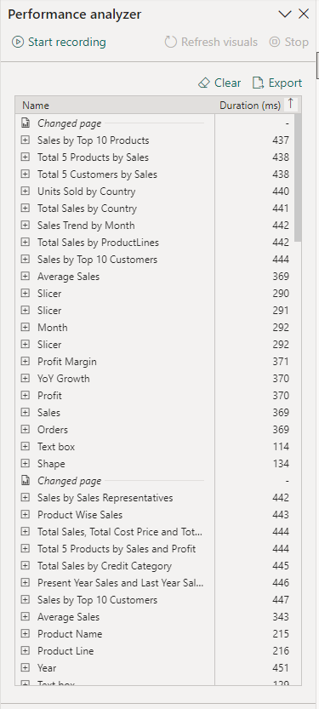

**Fig1. Performance Analyzer**

Duration Calculated in Millisecond’s.

Referring Performance Analyzer if set 10 Lakhs Records it will take hardly 1 min data and visualizations will be refreshed.

My Visualization Consists of 12 Reports.

1. Summary Report
2. Sales Report
3. Orders Report
4. Customer Report
5. Products Report
6. Payments Report
7. Employee Report
8. Employee Reports To
9. Office Report
10. Top/ bottom Performances
11. What If Analysis
12. Influencer
13. **Summary Report:**

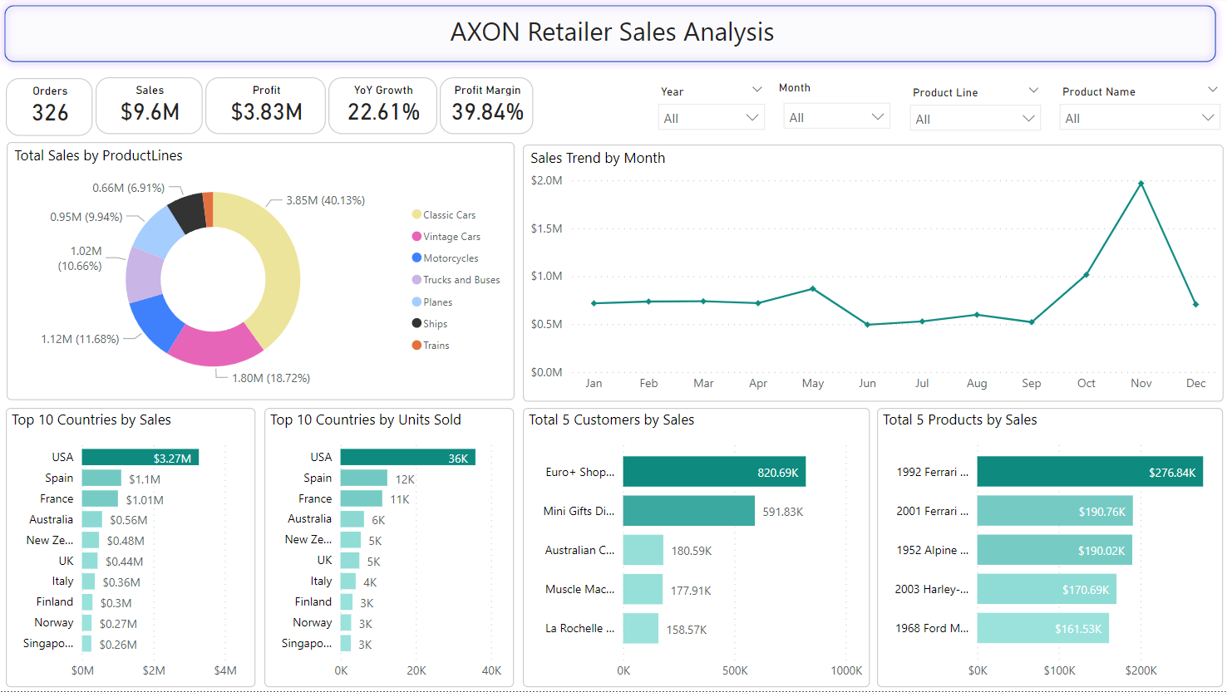

**Figure 1. Visualization of Summary Report**

The Summary report having visualizations such as

* Total Sales by Productlines
* Total Sales and units by country
* Top 5 customer sales
* Top 5 Product Sales
* Sales Trend Line

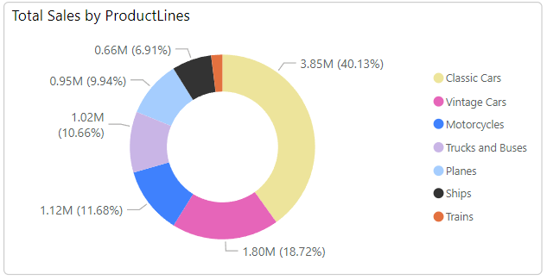

**Figure 1(a). Total Sales by Productlines**

The Donut Chart Showing the Distribution of sales on various Productlines. Created donut chart by taking Category on Legend, Sales on Values.

1. **Classics Cars**: This segment contributes most of the total sales for the 40% of total. Classic cars are a significant part of sales.
2. **Vintage Cars**: This segment contributes second in terms of sales, contributing approximately 18.72% of the total. They are a substantial part of sales but are less prominent than classic cars.
3. **Motorcycles**: Motorcycles account for about 11.68% of total sales, making them a noteworthy product line.
4. **Trucks and Buses**: Trucks and buses contribute around 10.66% of total sales, which is a significant portion.
5. **Planes:** Planes make up about 9.94% of total sales, indicating a smaller share.
6. **Ships**: Ships represent 6.91% of total sales, making them a smaller contributor compared to the previous product lines.

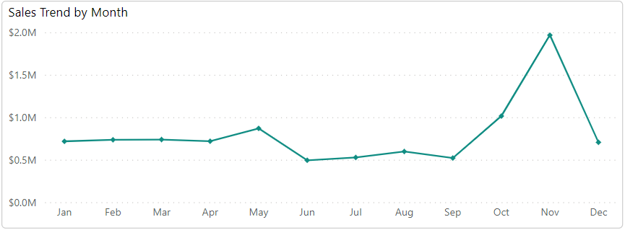

**Figure 1(b). Sales Trend Over Month**

October, November having more sales and June has lowest sales. The above figure showing the overall sales Not for any Particular year. To see year wise sales select a year on the slicer in Figure 1.

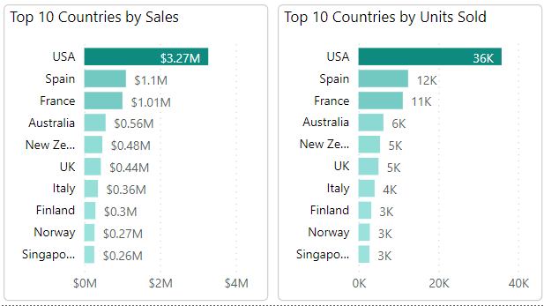

**Figure 1(c). Top 10 Sales and Units Sold by Country**

USA having More Sales $ 3.27M in the Top 10 Countries and also having More Units 36K Sold by USA

From the Top 10 Singapore having less sales $0.26M.

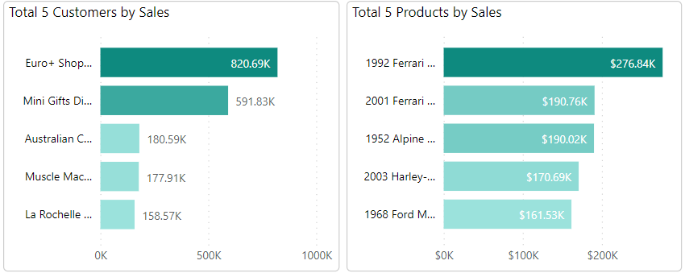

**Figure 1(d). Top 5 Customers and Top 5 Product by Sales**

1. **Euro+ Shopping Channel** had the highest Sum of Sales which is contributed 42.53% of sum of sales. From the top 5 “La Rochelle Gifts had the lowest sales.
2. **1992 Ferrari 360 Spider Red** producthad the highest sales which is contributed 27.97% of Total Sales. On the otherhand, 1968 Ford Mustang had the lowest sales contributed from Top 5 Sales.

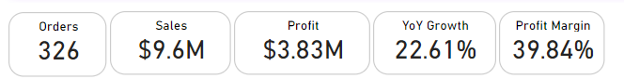

**Figure 1(e). Cards**

From Figure 1(e), Display the Total Orders, Total Sales, Total Profit, YoY Growth and Profit Margin.

1. **Orders Card:** displays the no of orders received from customers.
2. **Sales Card:** displaysthe sum of sales.
3. **Profit Card:** displays the total profit.
4. **YoY Growth Card:** displaysthe Growth difference from Last year.
5. **Profit Margin Card:** displaysthe Profit Margin of Total Sales.

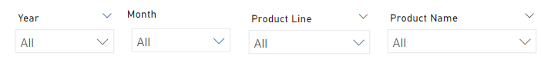

**Figure 1(f). Slicers**

1. **Year:** To Filter the year.
2. **Month:** To Filter by Month.
3. **Productline:** To filter by Each Productline.
4. **Product Name:** Filter by Products.

**Figure 2. Sales Report**

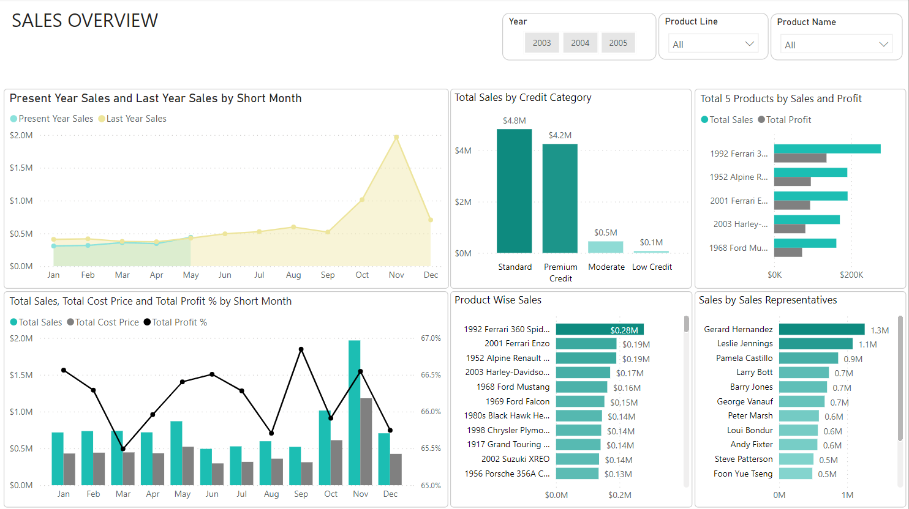

Sales Overview Report had following charts such as

1. Sales trend report comparison between present year and last year sales.
2. Clustered Bar Chart displays the Total Sales by Credit Category.
3. Clustered bar chart displays the comparison top 5 product sales and their profit.
4. Line and Clustered column chart having sales and cost price with profit % on trend line.
5. Clustered bar chart displays Product Wise Sales and Sales Represent wise Sales.

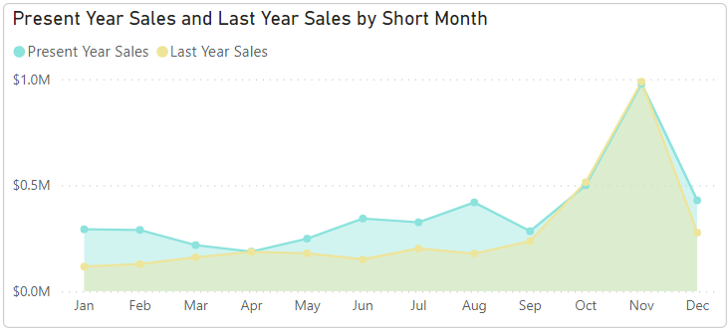

**Figure 2(a). Sales Trend of Present and Previous Year Sales**

From Figure 2(a),

* ﻿At $0.97M, November had the Contributed high Present Year Sales. On the Otherhand April had contributed which is the lowest Present Year Sales at $0.18M.﻿﻿
* ﻿﻿Present Year Sales and total Last Year Sales are positively correlated with each other.﻿﻿
* ﻿﻿November month Contributed 29.78% of Last Year Sales.﻿﻿
* ﻿﻿Present Year Sales and Last Year Sales diverged more when the Month was August, when Present Year Sales were $0.24M higher than Last Year Sales.﻿﻿
* Both years having more Sales on November Only.

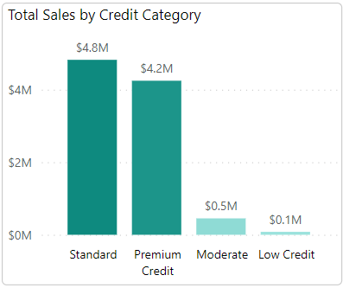

**Figure 2(b) Sales by Credit Category**

From Above Figure,

* Standard Category Accounted 50.22% of Total Sales.
* At the same time, Low Credit Category had a lowest sales among them.

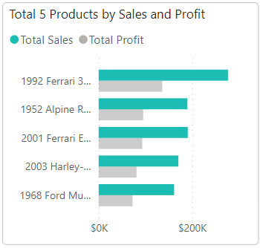

Figure 2(c) Top Products by Sales and their Profit.

From the above Figure,

* 1992 Ferrari 360 Spider red Contributed 27.97% of Total Sales.
* At the same time, 1968 Ford Mustang had a lowest sales among them.

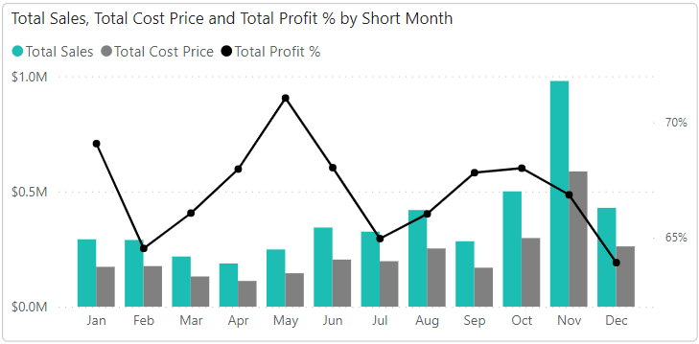

**Figure 2(d). Sales and Cost Price Difference along with Profit % Trend Line**

From the above figure,

* Sales and Profit Correlated Each other.
* November accounted more sales which is 21.69% of Total Sales.
* From all month’s sales in range between $0.18M and $0.98M.
* Total Profit Range from 63.91% to 69.08%.

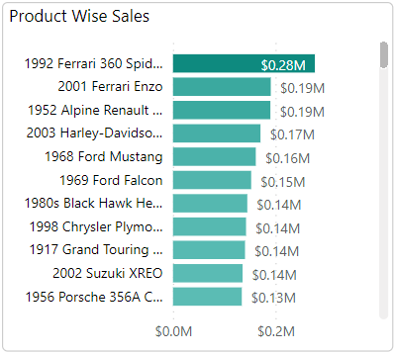

**Figure 2(e). Product Wise Sales**

From the above figure,

* 1992 Ferrari 360 Spider Red accounted for 2.88% of Total Sales.
* From 109 Products, Total Sales in range between $28K to $276K.
* 1939 Chevrolet Deluxe Coupe had lowest sales from all products.

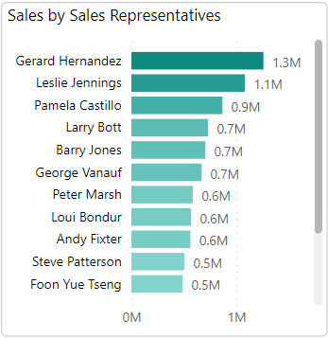

**Figure 2(f). Sales Contribution of Sales Persons**

From the above Figure,

* Gerard Hernandez had the highest sum of sales it was 262% more than Leslie Thompson who had the Lowest Sum of Sales.
* Gerard Hernandez contributed 13% of Total Sales.
* Across All Employees sum of sales ranged from $347K to $1.3M.

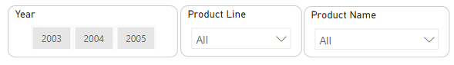Figure 2(g). Slicers

From above Figure,

* Visualizing data by using the above slicers with respect Year, Productline and Product Name.

**Figure 3. Order Details Report** 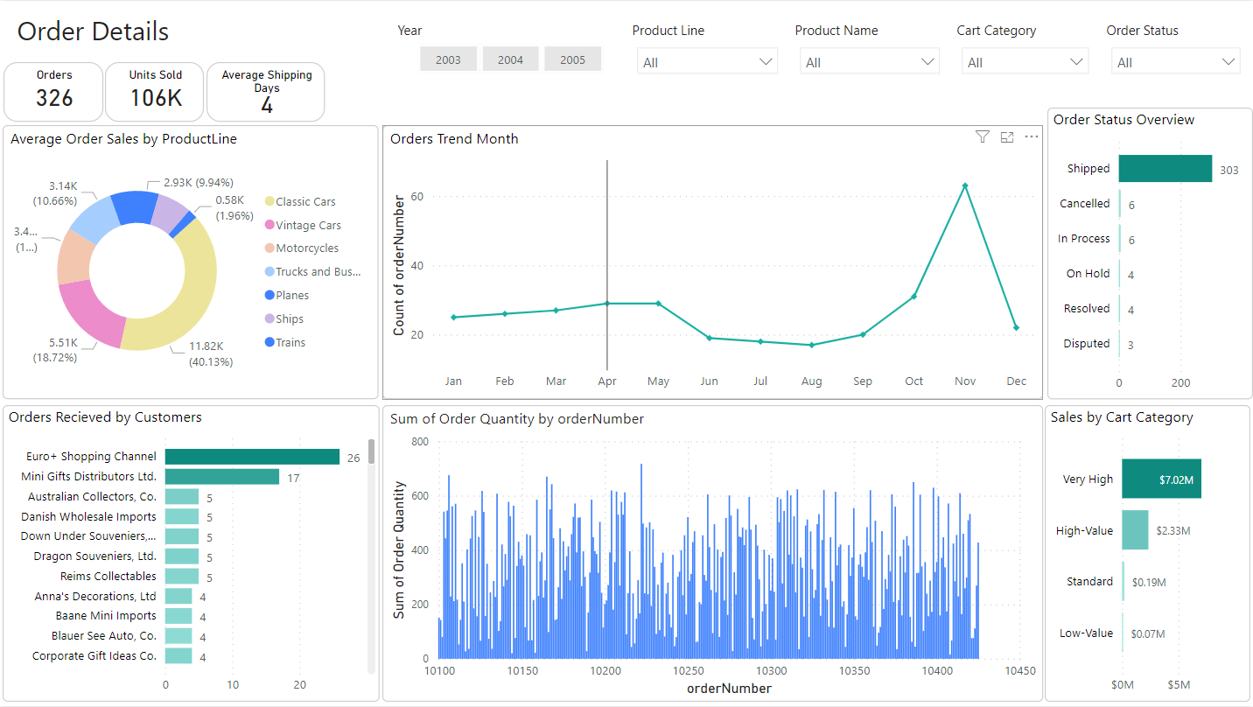

From above figure,

1. All order details presented at the above report. Such as average order value, orders trend, order received by customer, Order status, sales by Cart Category.

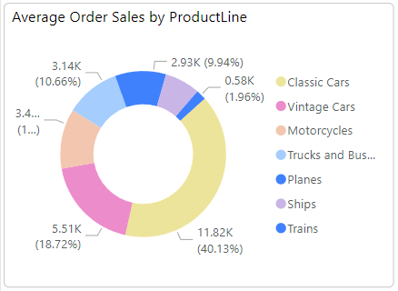

**Figure 3(a). Average Order Value by Productline.**

From above figure,

* Classic cars had high average order value of 40% from Total Average Order Value and Trains had lowest average order value at Trains 1.96% only.

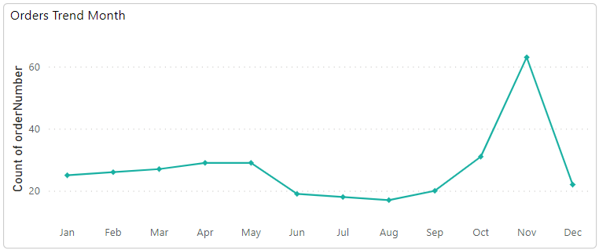

Figure 3(b). Orders Trend by Month

From above Figure,

* Overall Orders, November had a highest orders 63, followed by Oct and Apr.
* August had the lowest orders count 17.
* November accounted 19.33% of Orders count.
* Range of orders from all month 17 to 63.
* The above shows overall records report, by using slicers in the report we can overview the year wise, Product wise, productline wise, Cart category wise

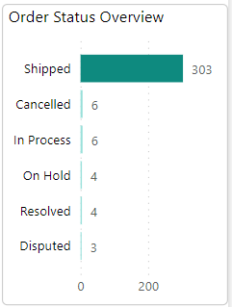

Figure 3(c). Orders status by the count

From above Figure,

* Almost all orders are shipped from orders received i.e., 326
* Shipping percentage is 92.94% from orders count.

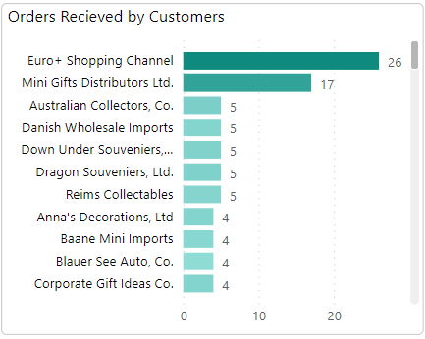

**Figure 3(d). Orders Received by Each Customer**

From the above the figure,

* Most Orders received from Euro+ Shopping Channel i.e., 26 followed by Mini Gifts Distributors Ltd.,
* Lowest orders received from Bavarian Collectables Imports, co i.e., 1
* Euro+ Shopping Channel accounted for 7.98% of Orders.

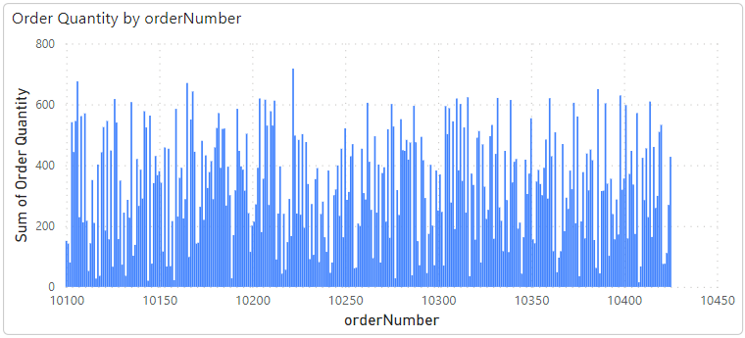

**Figure 3(d). Orders Count by Order Number**

From the above the figure,

* 10222 order number had the highest quantity of products i.e., 717
* 10408 order number had the lowest quantity of products i.e., 15

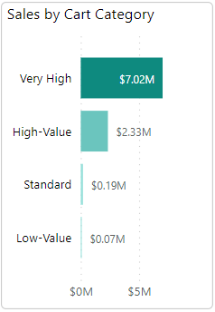

**Figure 3(e). Sale amount by Cart Category**

From the above figure,

* Very High had the highest Total Sales at $7M, followed by High-Value, Standard, and Low-Value.
* Very high accounted for 73.06% of Total sales.
* Low-Value category had the lowest total sales i.e., $0.07M

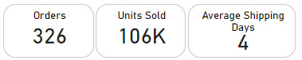

**Figure 3(f) Cards for Total Orders, Units Sold, and Average Ship date**

* Total No of orders , Total Units Sold and Average Ship date visualized in the cards.

**Figure 3(f). Slicers**

* Slicers for Year, Productline, products, cart category, order status are added for filtering data.

**Figure 4. Customer Details Report**

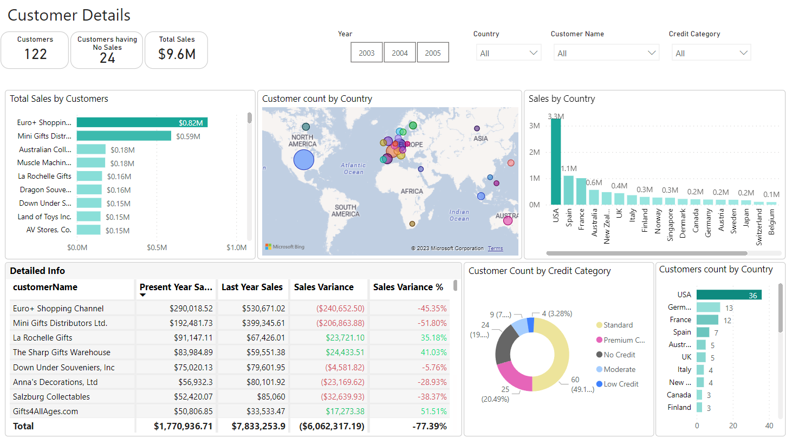

From the above report,

* 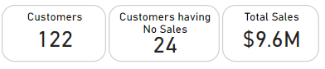Displayed all date related customers such as Total sales, Geographical location, Sales by their country, Sales variance, Count of Customer Credit Category, customer count by Country.

**Figure 4(a). Cards**

* Visualized the cards of no of customers, customer having no sales, total sales.

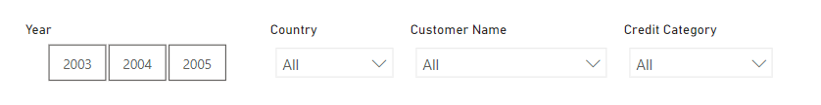**Figure 4(b). Slicers**

From the above Figure,

* Added a Year, Country, Customer Name, Credit Category Slicers.

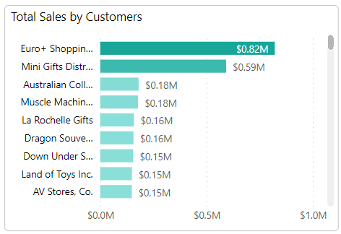

**Figure 4(c). Total Sales by Each customer**

From the above Figure,

* Visualize the Clustered bar chart, to display the total sales of each customer.
* Euro+ Shopping Channel had a highest sales $0.82M followed by Mini Gifts Distributors Ltd.,
* Boards & Toys Co. had a lowest sales of $0.01M .
* ﻿Euro+ Shopping Channel accounted for 8.55% of Total Sales.

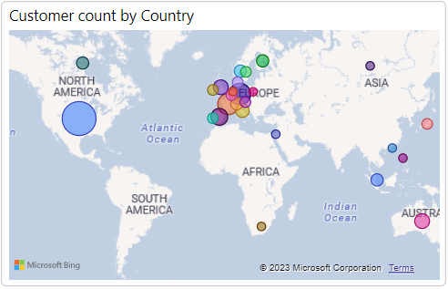

**Figure 4(d).Customers Location**

From the above figure,

* Visualized the Customer location by using Map Chart.
* USA has highest number of customers i.e., 36 followed by Germany and France.
* USA accounted for 29.51% of Customers.

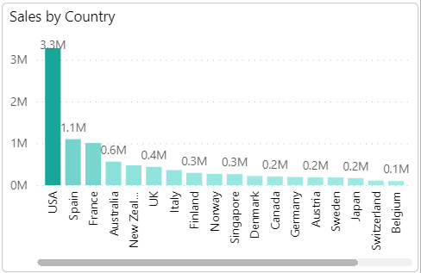

**Figure 4(e). Sales by Each Country**

From the above figure,

* Visualized the Stacked Column Chart by taking country on x-axis and Sales on y-axis
* USA had highest Sum of Sales $3.3M.
* Hong Kong which had the lowest Sum of Sales at 45K.

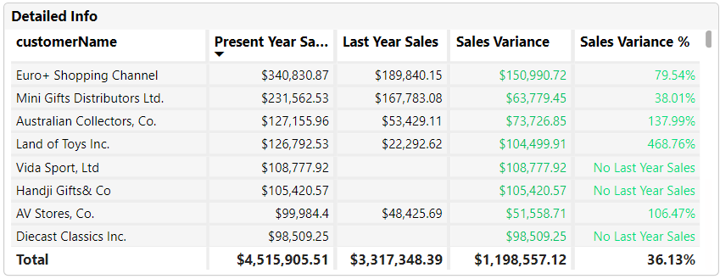

**Figure 4(f). Sales variance Table**

From the above figure,

* Visualized a table to show the sales variance and sales variance percentage by adding column names Customer name, Present Year Sales, Last Year Sales, Sales variance, Sales variance %
* If the Last year sales are more than present year sales sales variance showed as green color, if it is less showed text in red color, if there are no last year sales in sales variance % displayed a comment “No Last Year Sales”.

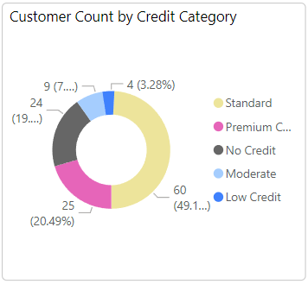

**Figure 4(g). Customer**

From above figure,

* Customer Count Separated by a Credit Category. Visualized a donut chart by taking Credit Category as a Legend and Customer Count as Values.
* Most the customers belong to Standard Category i.e., 49.18%. On the other hand, customers having low credit is very low i.e., 3.28%
* ﻿Standard category accounted for 49.18% of Count of Customers.

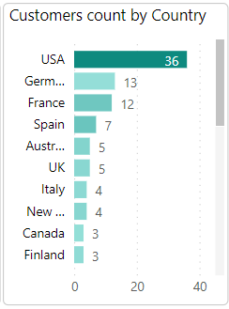

**Figure 4(h). Customer count by Country**

From the above figure,

* Counting the customers having by each country. Using Clustered bar chart by taking Count of Customer on X-axis, Country Names on Y-axis.
* USA had the highest no of customers 36 followed by Germany and France.

**Figure 5. Product Details Report**

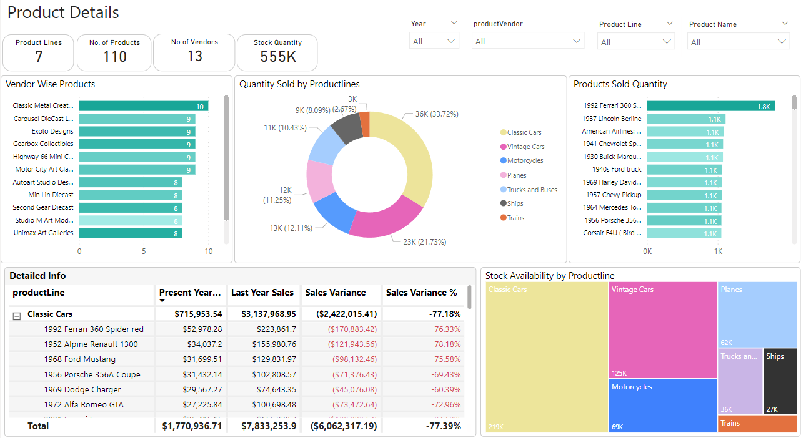

From the above figure,

* All details for Proudcts let you know from the figure.
* Here, we can explore the vendor wise product count, Stock sold by Productline, Products sales quantity, detailed product sales and variance info, Stock availability.

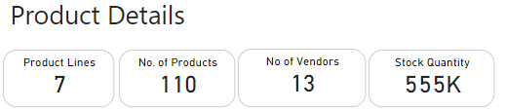

**Figure 5(a). Cards**

From the above figure,

* Visualized the cards such as Productlines, no of products, no of vendors and Stock Quantity.

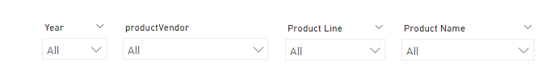

**Figure 5(b). Slicers**

From the above Figure,

* To filter the data, visualized the slicers such as Year, Product Vendor, Productline, Product Name

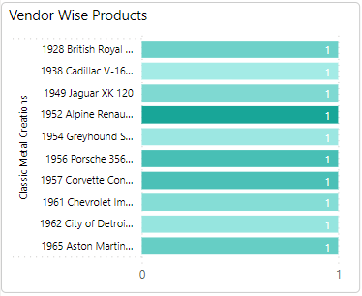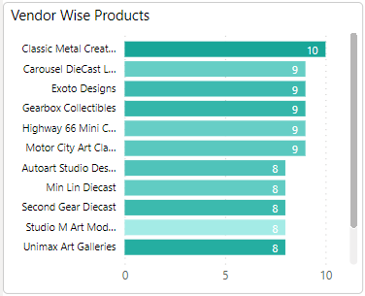

**Figure 5(c). Vendor Wise Products**

From the above,

* Created a Clustered bar chart by taking Product count on X-axis and Vendor Name on Y-axis.
* Classic Metal Creations had highest no of products i.e., 10.
* Red Start Diecast had lowest no of products i.e., 7.
* By Drill down on the Specified Vendor name we can see which products they have.

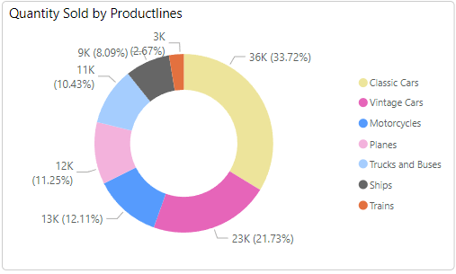

**Figure 5(d). Quantity Sold by Productlines**

From the above Figure,

* Created a Donut chart taking Productlines on Legend and Order Quantity on values.
* Classic Cars had highest sum of order quantity 33.72% followed by Vintage Cars and Motor Cycles.
* Trains had lowest quantity of sales 2.67%.
* Classic Cars accounted for 33.72% of Sum of Order Quantity.

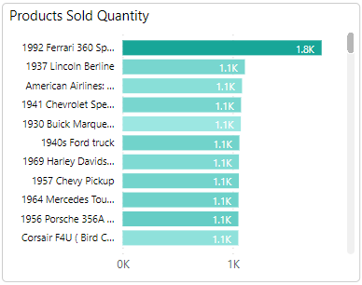

**Figure 5(e). Sold Quantity**

From the above Figure,

* To visualize Each Product Sold Quantity, created a Clustered bar chart taking Order Quantity on X-axis and Product Names on Y-axis.
* 1992 Ferrari 360 Spider red had the highest sold product followed by 1937 Lincoln Berline and American Airlines: MD-11S.
* 1957 Ford Thunderbird had the lowest sold product.

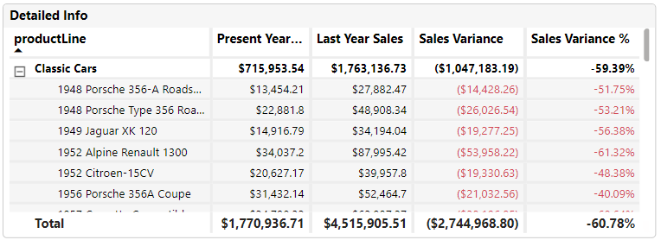

**Figure 5(f). Sales variance of each product and productline**

From the above figure,

* Created a matrix, to visualize the sales variance of Last Year and Present Year. By taking Productline and product on rows, Present year sales, Last year sales, Sales variance, Sales variance % in the values.
* On the above figure, slicer of year set to 2005. We have data till May 2005 Only. That’s why most of the product are having negative sales.

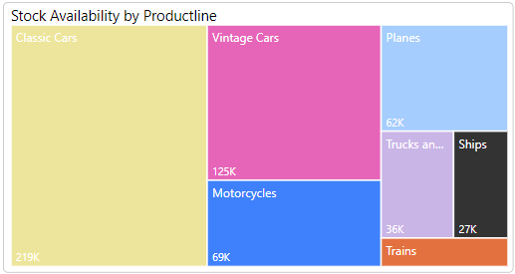

**Figure 5(g). Stock Availability of Each Productline.**

From the above figure,

* Created a Tree map to visualize the Stock availability of Each Productline by taking Category as Productline and Sum of Stock Quantity as Values.
* Classic Cars had the highest quantity of stock $219K followed by Vintage Cars and Motorcycles.
* Trains had the lowest stock 16K.

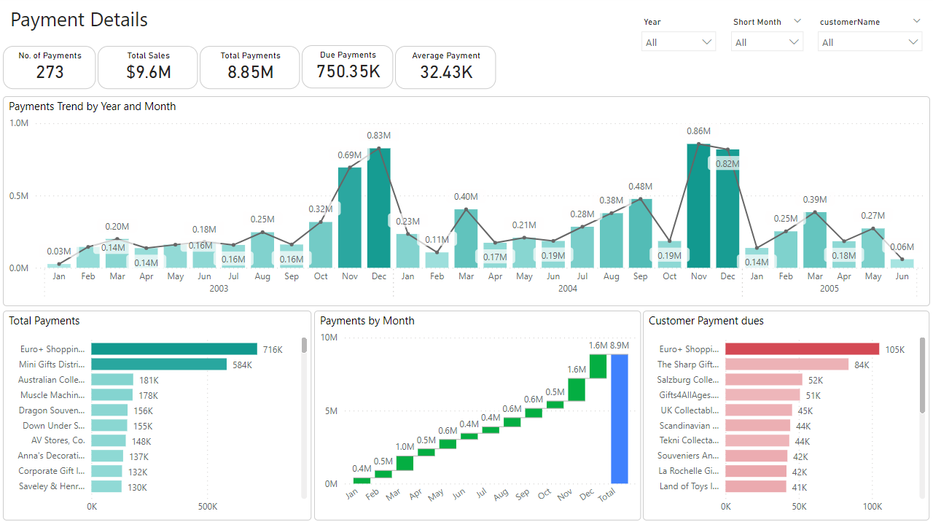

**Figure 6. Payment Details Report**

From the above figure,

* All details are created as a visualization charts such as Payments trend, total payments made by each customer, Payments by month, Payments due and slicers also.



**Figure 6(a). Cards**

From the above figure,

* Visualized the values as a cards. Total no of payments, Total Sales, Total Payments, Due Amount, Average Payments made.

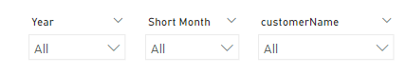**Figure 6(b). Slicers**

From the above figure,

* To visualize the report by Filtering as Year, Short Month, Customer Name.

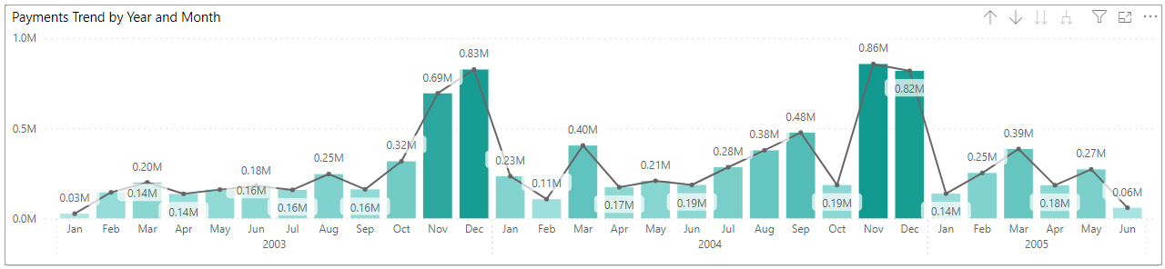

**Figure 6(c). Payments Trend over Year and Month**

From the above figure,

* To visualize the Payments Trend, created a Line and Stacked Column Chart by taking “amount” on Y-axis, Year,Short Month on X-axis and Total Payments as Line on Y-axis.
* In November and December received the highest payments overall.
* November in 2004 received highest payments followed by December 2003 and December 2004.
* Lowest payment received in January 2003.

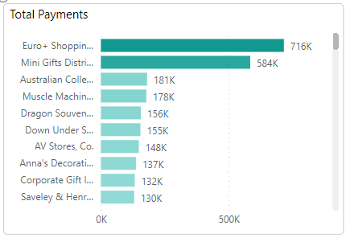

**Figure 6(d). Total Payments by Customers**

From the above Figure,

* To visualize the Total Payments of Each customer, created a Clustered bar chart by taking Sales on X-axis and Customer name on Y-axis.
* Euro+ Shopping Channel Paid the highest of total payments followed by Mini Gifts Distributors Ltd and Australian Collectors Co
* Boards & Toys Co. paid the lowest of total payments.

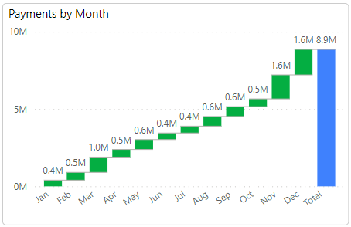

**Figure 6(e). Total Payments by Month.**

From the above figure,

* To visualize the Total Payments of Cumulative Each month, created a Waterfall Chart by taking Short Month on Category and Total Payments on Y-axis.
* December had the highest payments received followed by November and March.

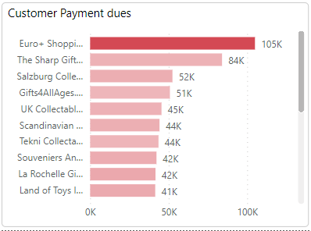

**Figure 6(f). Payment Dues by Customers**

From the above figure,

* To Visualize the total pending payments of Each Customer, created a Clustered bar chart taking due payments on X-axis and Customer Names on Y-axis.
* Euro+ Shopping Channel had highest payment due followed by The Sharp Gifts Warehouse and Salzburg Collectables.
* Handji Gifts & Co had lowest payments due.

**Figure 7. Employee Details Report**

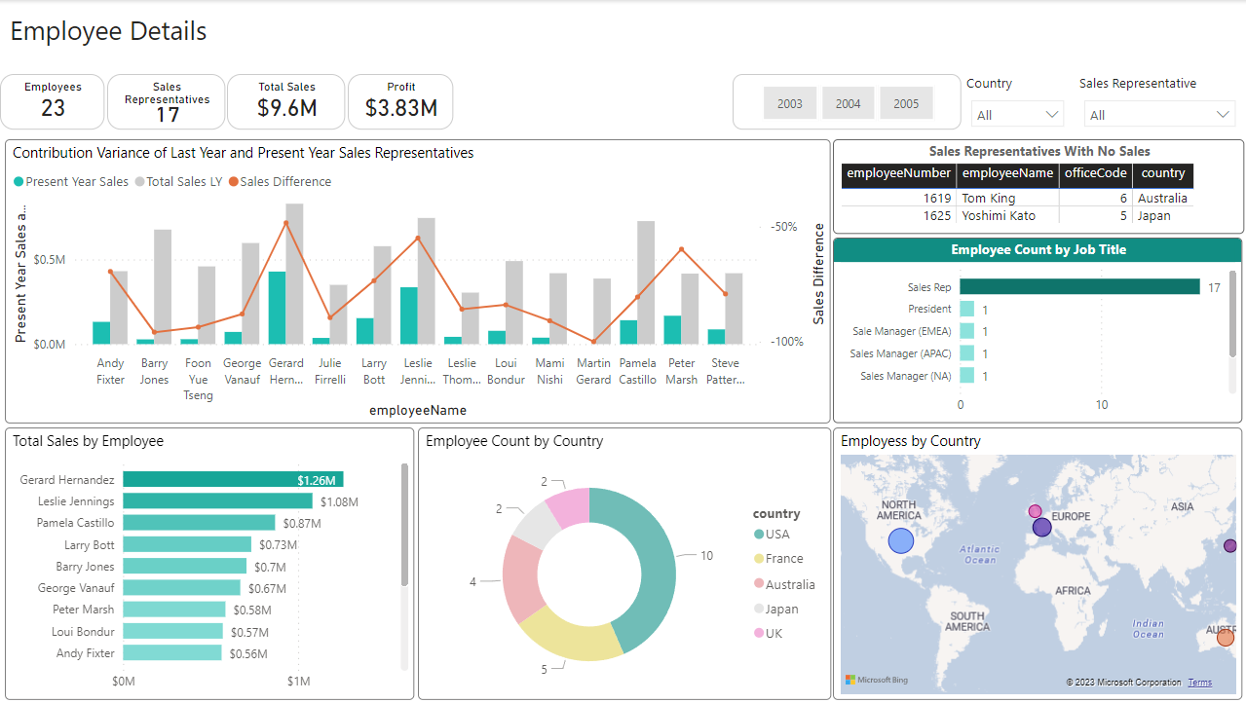

From the above figure,

* All details of employee such as Sales Contribution , Performance, Count, Location, Jobtitle count

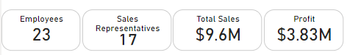

**Figure 7(a). Cards**

* Total Employees, No of Sales Representatives, Total Sales, Profit showed in Cards.

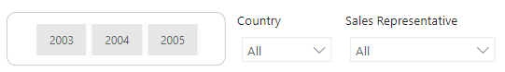

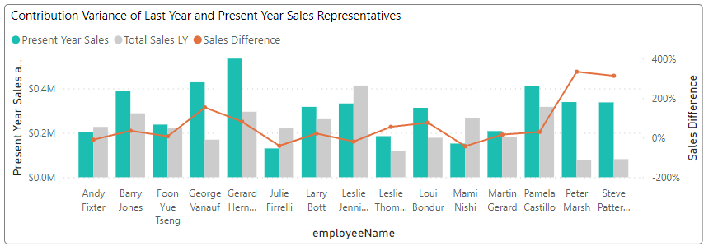

**Figure 7(c) Sales Performance of Last year and Present Year**

From the above figure,

* To see the performance variance of each employee by last year and present year, created a Line and Clustered Column chart taking Present Year Sales and Last year sales on Y-axis, Employee names on X-axis and Sales difference percentage on Line y-axis column.
* The above chart data according to Year 2004, Gerard Hernandez had the highest Present Year Sales and having Sales difference from last year is 81.06% Growth.
* Peter Marsh had better Sales difference of 333.55% Growth in 2004.

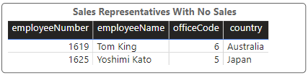

**Fig 7(d). Sales Represents having No Sales.**

From the Above Figure,

* To display Sales Represents having No Sales created a table taking employeeNumber, employeeName, officeCode, country as a columns.
* Tom King and Yoshimi Kato had never contributed any Sales.

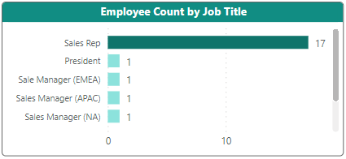

**Figure 7(e) Employee Count by Job Title**

* Sales Representatives had the highest count Remaining all positions had Each 1 count.

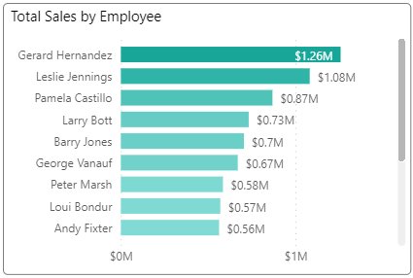

Figure 7(f). Total Sales by Employee

From above figure,

* To visualize the sales by Each Employee, created a Clustered bar chart by taking Sales on X-axis and Employee Names on Y-axis.
* Gerard Hernandez had contributed highest sales $1.26M followed by Leslie Jennings and Pamela Castillo
* Leslie Thompson Contributed lowest sales from all sales representatives i.e., $0.35M

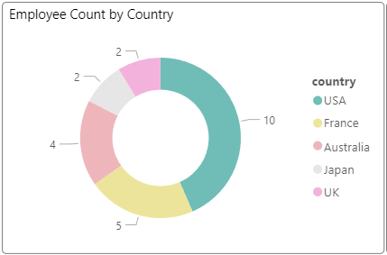

**Figure 7(g). Employee Count by Country**

From above figure,

* To visualize the which country had how many employees, created a Donut Chart by taking Country on Category and Employee number on Values.
* USA had highest no of employees 10 followed by France and Australia.

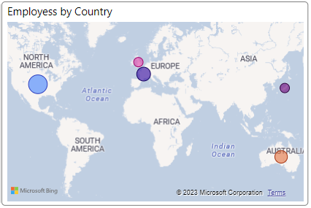

Figure 7(h). Employee Location

From the above figure,

* To visualize the employee location, created a Map chart by taking Country as Location, Country as Legend and Employee Count as Bubble Size.

**Figure 8. Employee Reports to Higher**

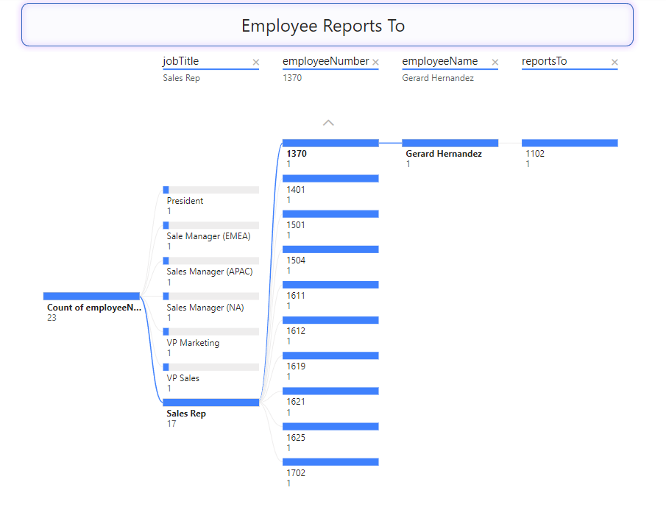

From the above figure,

* To visualize the hierarchy, created a Decomposition Tree by taking Employee count on “Analyze”, “jobTitle”, “employeeNumber”, “employeeName”, “reportsTo” on Explain by

**Figure 9. Office Report**

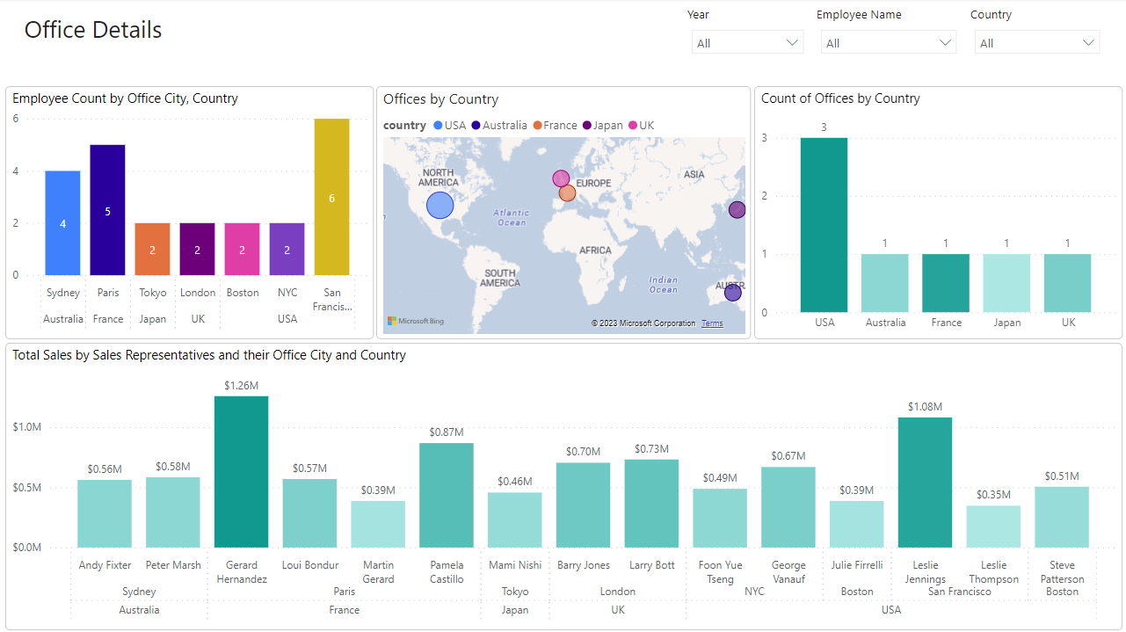

From the above figure all details visualized such as Employee count by office.

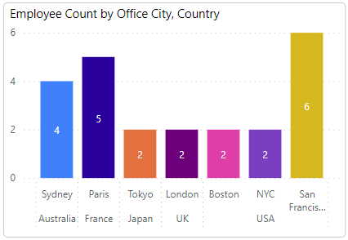

Figure 9(a). Employee Count

From the above figure,

* To count the employees by office Country and City, created a Staked Column Chart by taking “Country”, “City” on X-axis, Employee count on Y-axis, City as Legend.
* San Franciso had highest no of employees followed by Paris and Sydney.

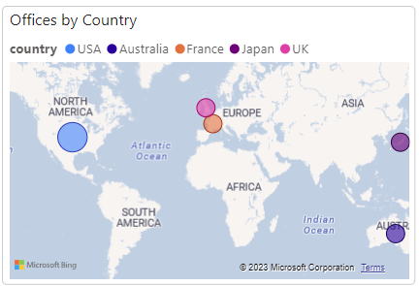

**Figure 9(b). Office Location**

From the above figure,

* To visualize the location of offices, created a Map Chart by taking “Country”, “City” on Location, “Country” on Legend and “Office” count on Bubble size.
* ﻿USA had the highest Count of offices 3.

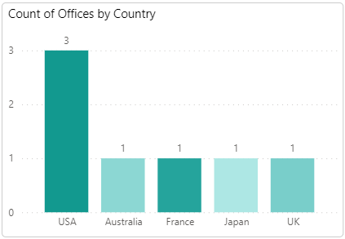﻿

Figure 9(c). Count of Offices

From the above figure,

* To visualize the count of offices in Each country, created Clustered Column Chart by taking count of offices on Y-axis and Country Name on X-axis.
* USA had the highest count of offices.

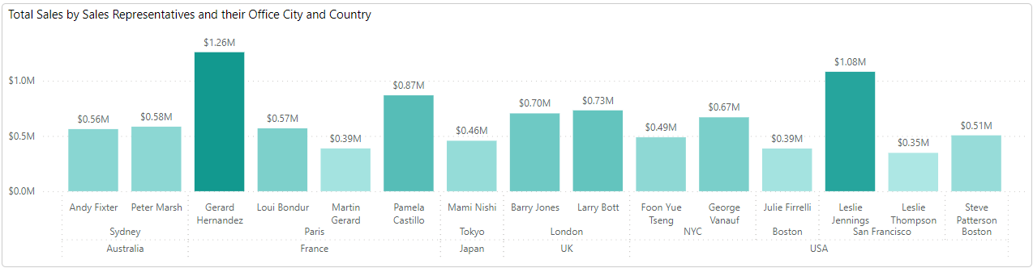

Figure 9(c). Sales by Each Representative

From the above figure,

* To visualize the sales by each Sales Representative by office City and Country, created a Clustered column bar chart by taking “Country”, “City” and “Employee Name” on X-axis and “Total Sales” on Y-axis.
* Gerard Hernandez contributed the highest sales followed by Lesslie Jennings and Pamelo Castillo.

**Figure 10. Top and Low Performances**

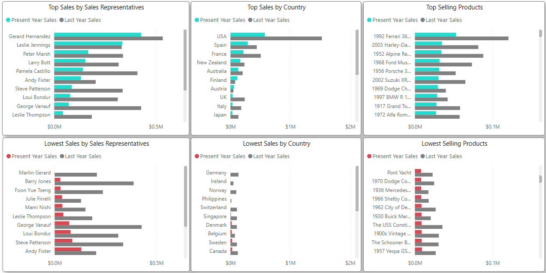

From the above figure,

* Visualized Top and Low Performances of all various categories.

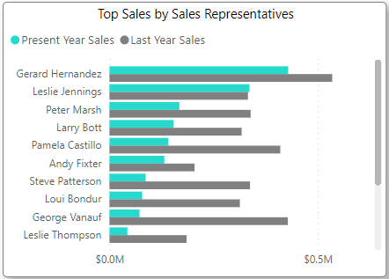

**Figure 10(a) Top Sales by Sales Representatives**

From the above figure,

* To visualize the Top sales and Sales variance of Employee, created a Clustered bar chart by taking “Employee Name” on Y-axis and Present Year Sales and Last Year Sales on X-axis.
* Gerard Hernandez had highest Present year sales followed by Leslie Jennings, Peter Marsh in 2005.
* Gerard Hernandez had highest Last year sales followed by George Vanauf and Pamela Castillo in 2004.

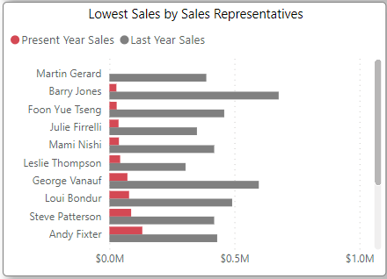

**Figure 10(b) Lowest Sales by Sales Representatives**

From the above figure,

* To visualize Lowest Sales of Sales Representative, created a Clustered bar chart by taking “Employee Name” on Y-axis and Present Year Sales and Last Year Sales on X-axis. Set the Sort Axis to Present Year Sales 🡪 ascending
* Martin Gerard had the lowest Present Year Sales, Representative in 2005 followed by Barry Jones and Foon Yue Tseng
* Leslie Thompson had the lowest Last Year Sales Representative in 2004 followed by Julie Firrelli and Martin Gerard.

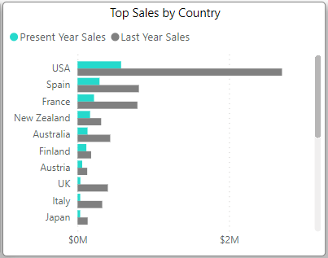

**Figure 10(c) Top Sales Countries**

From the above figure,

* To visualize the Top Sales of Country, created a Clustered bar chart by taking “Country” on Y-axis and “Present Year Sales” and “Last Year Sales” on X-axis and Set Sort Axis to Descending.
* USA had highest Present Year Sales in 2005 followed by Spain and France.
* USA had highest Last Year Sales in 2004 followed by Spain and France.

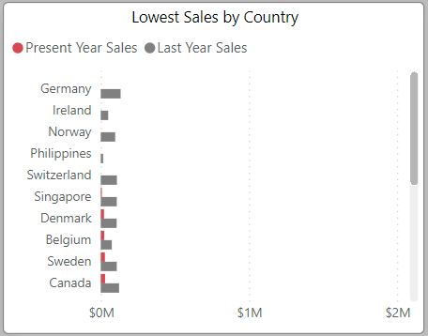

**Figure 10(d). Lowest Sales Countries**

From the above Figure,

* To visualize the Lowest Sales of Each Country, created a Clustered bar chart by taking “Country” on Y-axis and “Present Year Sales” and “Last Year Sales” on X-axis.
* Germany, Ireland, Norway, Philippines, Switzerland had the No Sales in the 2005.
* For the present year, Singapore had the lowest sales in 2005 followed by Denmark and Belgium.
* For the last year, Philippines had lowest Last year sales in 2005 followed by Austria and Ireland.

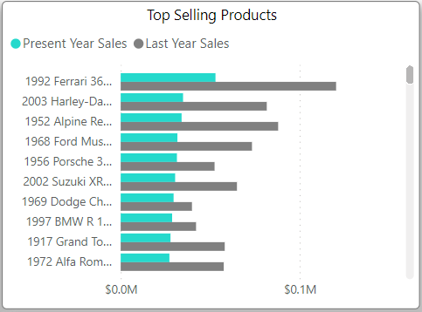

**Figure 10(e). Top Selling Products**

From the above figure,

* To visualize the Top selling products , created a clustered bar chart by taking “Product Name” on Y-axis and “Present Year Sales” and “Last Year Sales” in X-axis.
* 1992 Ferrari 360 Spider Red had highest “Present Year Sales” followed by 2003 Harley-Davidson Eagle Drag Bike and 1952 Alphine Renault 1300.
* 1992 Ferrari 360 Spider Red had highest “Last Year Sales” followed by 2001 Ferrari Enzo and 1952 Alphine Renault 1300.

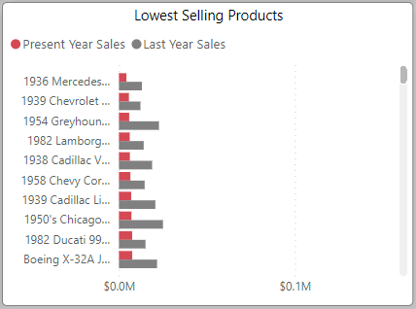

**Figure 10(f). Lowest Selling Products**

From the above figure,

* To Visualize the Lowest Selling Products, created a Clustered Bar Chart by taking “Product Name“ on Y-axis and “Present Year Sales” and “Last Year Sales” on X-axis.
* 1936 Mercedes Benz 500k Roadster had lowest “Present Year Sales” in 2005 followed by 1939 Chevrolet Deluxe Coupe and 1954 Greyhound Scenicruiser.
* 1939 Chevrolet Deluxe Coupe had lowest “Last Year Sales” in 2005 followed by 1936 Mercedes Benz 500k Roadster and 1982 Lamborghini Diabloe.

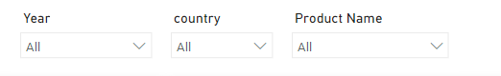

**Figure 10(g). Slicers**

**Figure 11. What If Analysis**

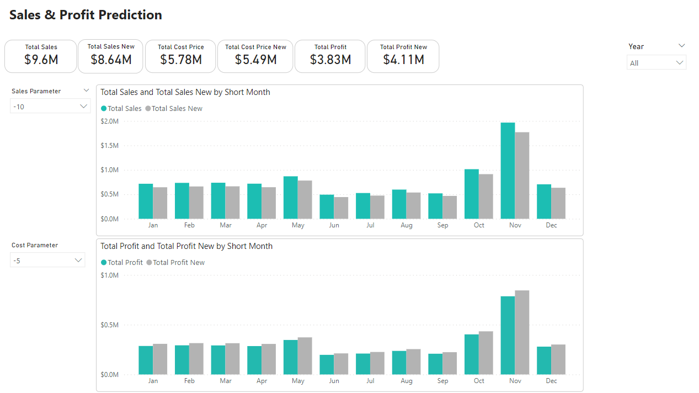

From the above figure,

* To visualize the what if analysis on Total Sales and Cost Price created a bar Clustered column Chart.

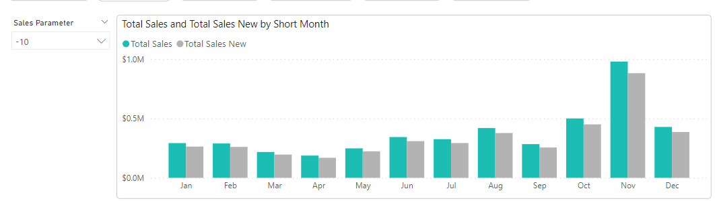

Figure 11(a). What If analysis on Total Sales

* To visualize the Total Sales and Totals Sales New (“What If Analysis”), created a Clustered Column Chart by taking “Short Month” on X-axis and “Total Sales”, “Total Sales New” on Y-axis.
* If the Sales Parameter Set to -10 then there is decrease of 10% in Total Sales New .

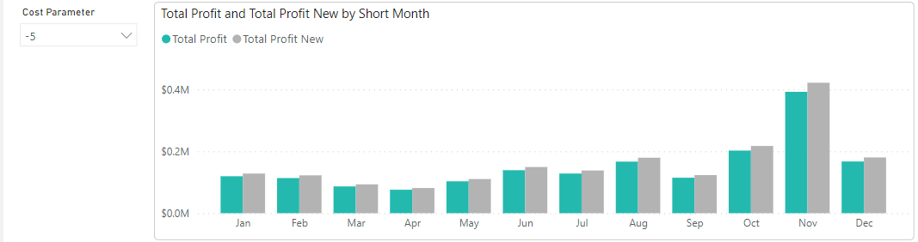

Figure 11(b). What If Analysis on Cost Price.

From the above figure,

* To visualize the Total Profit and Totals Profit New (“What If Analysis”), created a Clustered Column Chart by taking “Short Month” on X-axis and “Total Profit”, “Total Profit New” on Y-axis.
* If the Profit Parameter Set to -5 then there is increase of 10% in Total Profit New .



Figure 11(c) Cards

From the above figure,

* Visualize the total sales, Total New Sales (What If Analysis), Total Cost Price, Total Cost Price New (What If Analysis), Total Profit, Total Profit New (What If Analysis)

**Figure 12. Influencer**

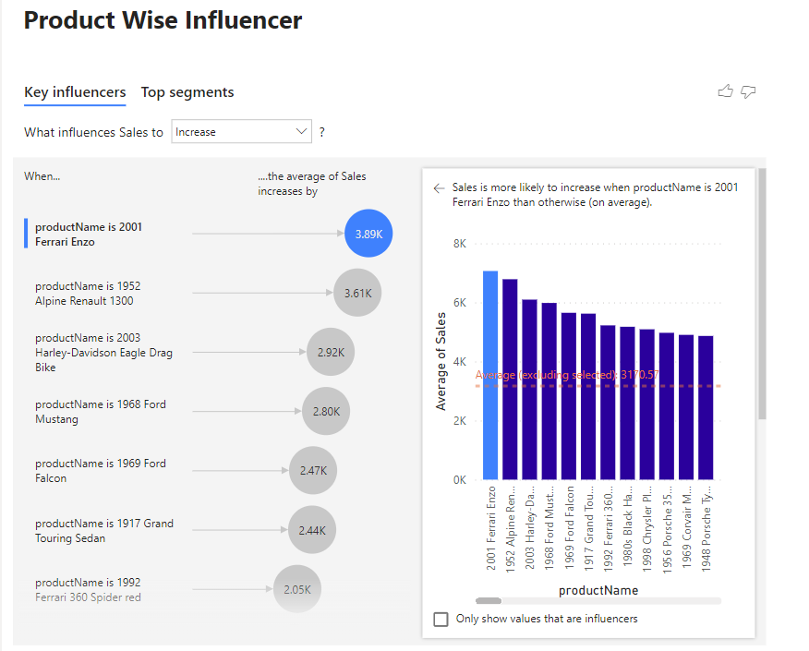

**Recommendations & Strategies:**

1. **Historical Data Analysis:**

* To better understand the sales trends, it's crucial to have access to historical sales data. This will allow you to identify seasonality, growth patterns, and other important trends that can inform your sales strategy.

1. **Market Research:**

* Consider conducting market research to understand the demand for these products. This can help in setting realistic sales targets and identifying potential opportunities.

1. **Product Promotions:**

* Develop a marketing and promotion strategy to increase sales. This could include online advertising, social media campaigns, or other methods to reach potential customers.

1. **Customer Engagement:**

* Building and maintaining strong customer relationships. This can lead to repeat business and referrals**.**

1. **Pricing Strategy:**

* Analyze your pricing strategy to ensure it is competitive in the market. Consider offering discounts or special promotions to attract more customers.

1. **Sales Team Training:**

* If applicable, ensure that your sales team is well-trained and motivated to sell these products effectively. Take a look on who’s performance is low encourage them grow sales.

1. **Customer Feedback:**

* Collect and analyze customer feedback to make improvements to your products and services.

1. **Cost Reduction:**

* Evaluate your cost structure and identify areas where you can reduce costs without compromising product quality.

1. **Inventory Management**:

* Keep a close eye on your inventory levels to avoid overstocking or stockouts. Efficient inventory management can save costs and optimize sales.

**KEY POINTS**

1. Classics Cars segment had highest sales 40% of Total Sales followed by Vintage Cars with 18.72% and Motor Cycles with 11.68%. Classic cars are a significant part of sales.
2. USA had accounted for 34% of Total Sales followed by Spain 11.45% and France 10.52%. Honkong had lowest Sales.,
3. Euro+ Shopping Channel had the highest Total Sales which is contributed 42.53% of sum of sales. From the top 5 “La Rochelle Gifts had the lowest sales.
4. 1992 Ferrari 360 Spider Red product had the highest sales which is contributed 27.97% of Total Sales. On the otherhand, 1968 Ford Mustang had the lowest sales contributed from Top 5 Sales.
5. November accounted more sales which is 21.69% of Total Sales.
6. November had a highest orders 63, followed by Oct and Apr.
7. August had the lowest orders count 17.
8. November accounted 19.33% of Orders count.
9. Almost all orders are shipped from orders received i.e., 326.
10. Shipping percentage is 92.94% from orders count.
11. Gerard Hernandez had the highest sum of sales it was 262% more than Leslie Thompson who had the Lowest Sum of Sales.
12. Gerard Hernandez contributed 13% of Total Sales.
13. Most Orders received from Euro+ Shopping Channel i.e., 26 followed by Mini Gifts Distributors Ltd., i.e., 17.
14. 10222 order number had the highest quantity of products i.e., 717
15. 10408 order number had the lowest quantity of products i.e., 15
16. Very High had the highest Total Sales at $7M, followed by High-Value, Standard, and Low-Value.
17. Very high accounted for 73.06% of Total sales.
18. USA had highest Sum of Sales $3.3M. At the Sametime Hong Kong which had the lowest Sum of Sales at 45K.
19. USA has highest number of customers i.e., 36 followed by Germany and France. USA accounted for 29.51% of Customers.
20. Most the customers belong to Standard Category i.e., 49.18%. On the other hand, customers having low credit is very low i.e., 3.28%.
21. Vendor: Classic Metal Creations had highest no of products i.e., 10. Red Start Diecast had lowest no of products i.e., 7.
22. Classic Cars had highest sum of order quantity 33.72% followed by Vintage Cars and Motor Cycles.
23. Classic Cars had the highest quantity of stock $219K followed by Vintage Cars and Motorcycles. Trains had the lowest stock 16K
24. November in 2004 received highest payments followed by December 2003 and December 2004. Lowest payment received in January 2003.
25. Euro+ Shopping Channel Paid the highest of total payments followed by Mini Gifts Distributors Ltd and Australian Collectors Co
26. Euro+ Shopping Channel had highest payment due followed by The Sharp Gifts Warehouse and Salzburg Collectables. Handji Gifts & Co had lowest payments due.
27. According to Year 2004, Gerard Hernandez had the highest Present Year Sales and having Sales difference from last year is 81.06% Growth.
28. Peter Marsh had better Sales difference of 333.55% Growth in 2004.
29. Martin Gerard had the lowest Present Year Sales, Representative in 2005 followed by Barry Jones and Foon Yue Tseng.

**CONCLUSION:**

1. **Improved Decision-Making:**

This project will empower the company with data-driven insights, enabling better decision-making in areas like product development, marketing, and inventory management.

1. **Efficiency:**

Streamlining data management and automating certain tasks will save time and resources, allowing employees to focus on more strategic activities.

1. **Competitive Advantage:**

Effective sales data management and analysis can give the company a competitive edge by identifying untapped market opportunities and optimizing their sales strategies.

1. **Customer Satisfaction:**

By understanding customer behavior through data analysis, the company can tailor its products and services to better meet customer needs, potentially leading to higher customer satisfaction.

1. **Profitability:**

Ultimately, the project can contribute to increased profitability through more efficient sales operations and revenue optimization.